**Expand/Collapse All Group boxes**

1. **Overview**

This widget is used can be used to Expand and Collapse all the Group Boxes. This contains 2 Buttons Expand All and Collapse All which on clicking Expand and Collapses the Group boxes.

1. **Introduction**

This Pluggable Widget is Used to expand and collapse the Group boxes.

1. **Description**

The Widget is a Pluggable written in Custom Java Script Code. This Widget can be used to Expand and collapse two or more group boxes at once.

1. **Usage**

If you implemented two or more group boxes in your project with the help of Groupbox widget you can just download this widget to Implement Expand and Collapse All Button for it.

1. **Pre Requisites**

NA

1. **Limitations**
   1. Users can Just Download and place the widget wherever they want to Implement Expand and Collapse All for a Groupbox.
   2. This Widget can both Expand and Collapse all the Group Boxes.
   3. This Widget works only on the Groupbox.
2. **Dependencies**

It will work with the Mendix version above 9 or higher.

1. **Installation**
2. To import the component, click on App in menu and select Show App Directory in Explorer.

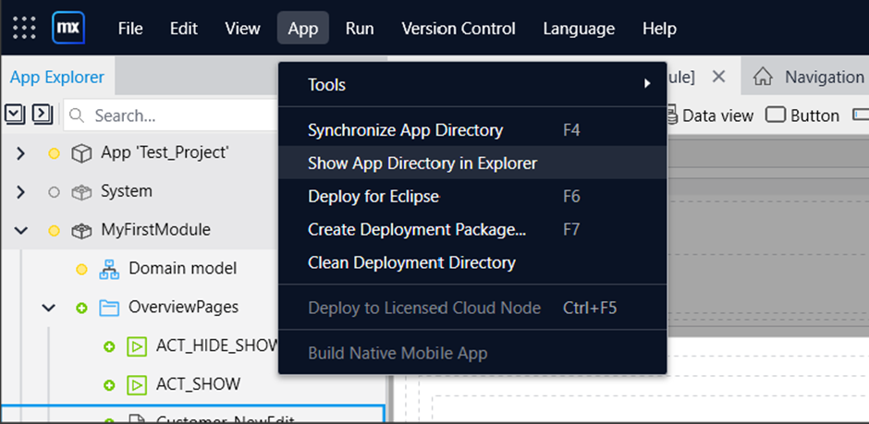

1. Open the Widgets folder in app directory and place your Mendix package there.

1. Then, Synchronize your App Directory on Mendix Platform by clicking on Synchronize App Directory under App in menu .

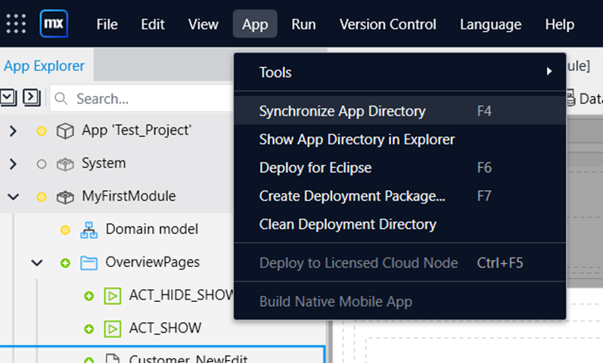

1. Once you Synchronize your app directory in mendix , you would be able to see your newly imported widget/component and then you can start using it.

